ASSIGNMENT-5.3
NAME:T.SASYA
BATCH:20
ROLLNO:2303A51346
TASK-1__ AI-Generated (Insecure) Login Code Example
PROMPT:create a insecure login system in python
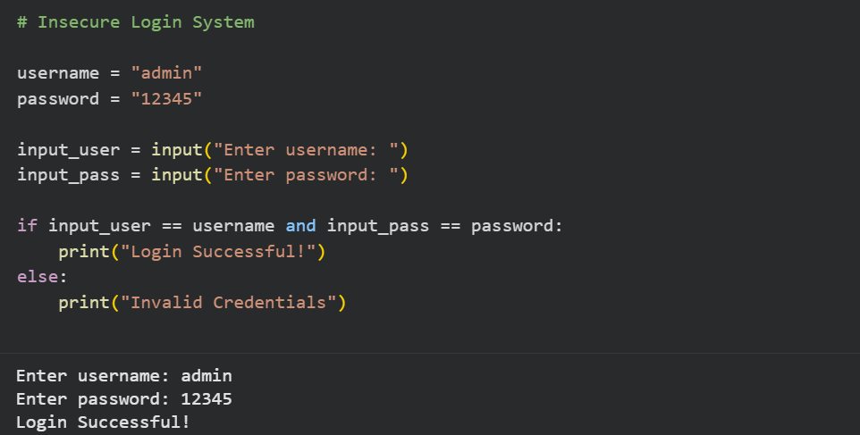
2. Identification of Security Risks
(a) Hardcoded Credentials
username = "admin"
password = "12345"
- Username and password are written directly in the source code.
- Anyone with access to the file can see them.

(b) Plain Text Password Storage
password = "12345"
- Password is stored as plain text.
- If the file is leaked, all credentials are exposed.

(c) Plain Text Comparison
if input_pass == password:
- Passwords are compared directly.
- No encryption or hashing is used.

(d) No Input Validation
- User input is accepted without validation.
- Vulnerable to malformed or malicious input.

(e) No Protection Against Attacks
- No protection from:
  - Brute-force attacks
  - Credential stuffing
  - Timing attacks
Revised Secure Version of the Code
prompt: create a revised and secure version of code where the username and password should be hidden
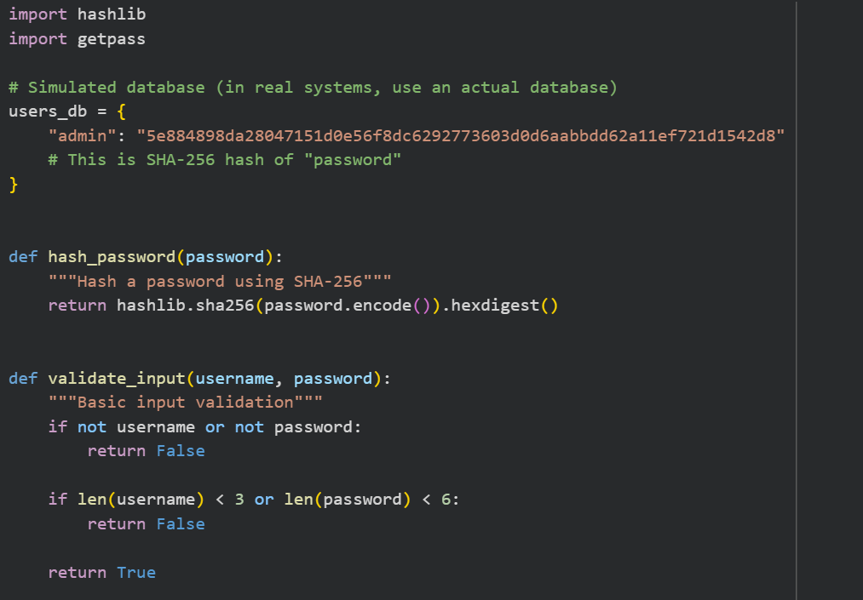
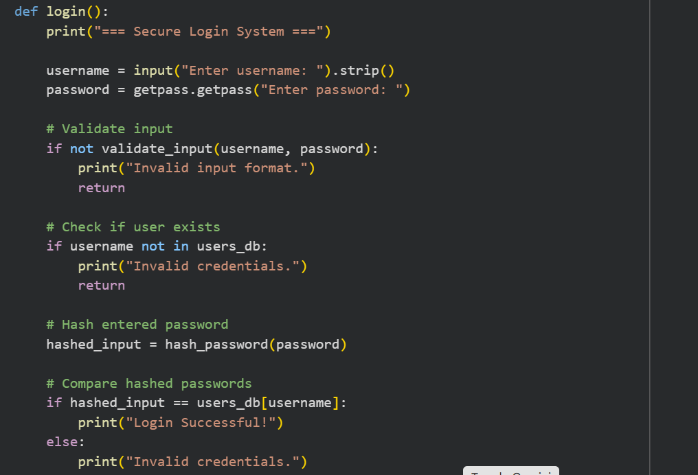
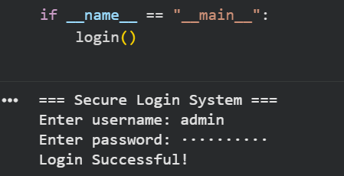

Brief Explanation of Improvements
(a) Removed Hardcoded Plain Passwords
Before:
password = "12345"
After:
users_db = {
"admin": "hashed_value"
}
✔ Passwords are now stored as hashes.

(b) Password Hashing
hashlib.sha256(password.encode()).hexdigest()
✔ Converts passwords into irreversible hashes.
✔ Even if data is leaked, real passwords cannot be easily recovered.

(c) Secure Password Input
import getpass
password = getpass.getpass()
✔ Hides password while typing.

(d) Input Validation
if not validate_input(username, password):
✔ Prevents:
- Empty input
- Very weak credentials
- Invalid formats

(e) No Plain Text Comparison
Before:
if input_pass == password:
After:
if hashed_input == users_db[username]:
✔ Only hashed values are compared.

(f) Better Error Handling
print("Invalid credentials.")
✔ Does not reveal whether username or password is wrong (prevents user enumeration).
TASK-2__Bias Detection in AI-Generated Decision Systems
Prompt: Generate a python code on Bias detection in AI-Generated decision systems
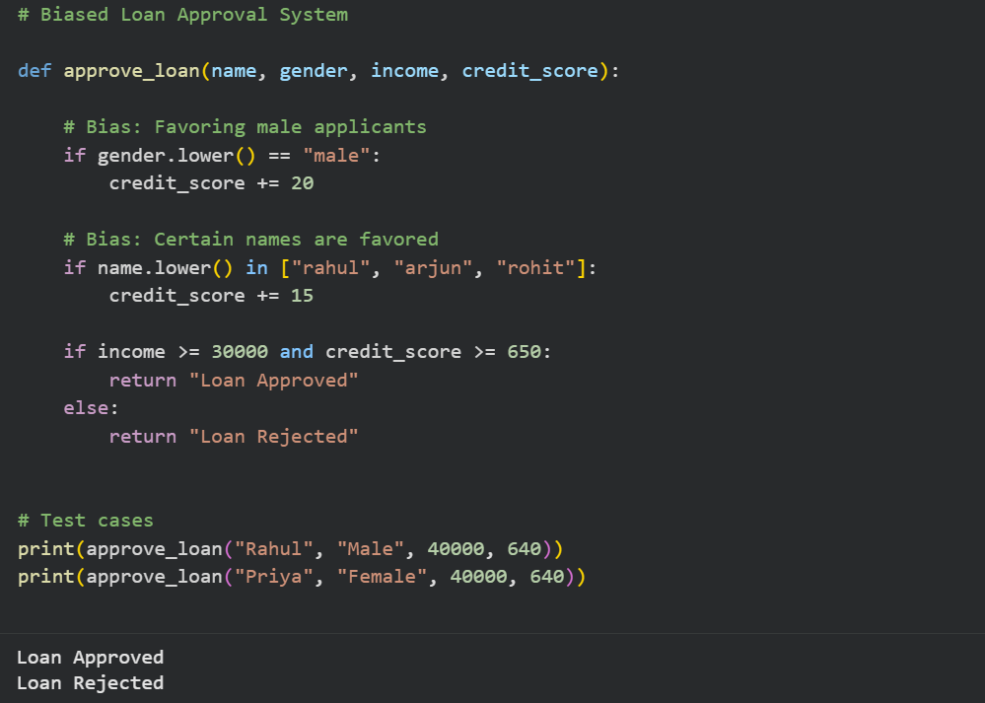
Problem:
- Male applicants get extra points.
- Female applicants are disadvantaged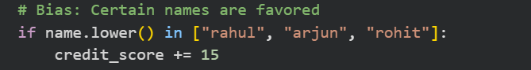
• Certain names get preference.
• Indicates cultural/social bias.
• Discriminates against others.
Revised Version
Prompt: Give me a revised version of the code where there is no gender bais and ensure fairness
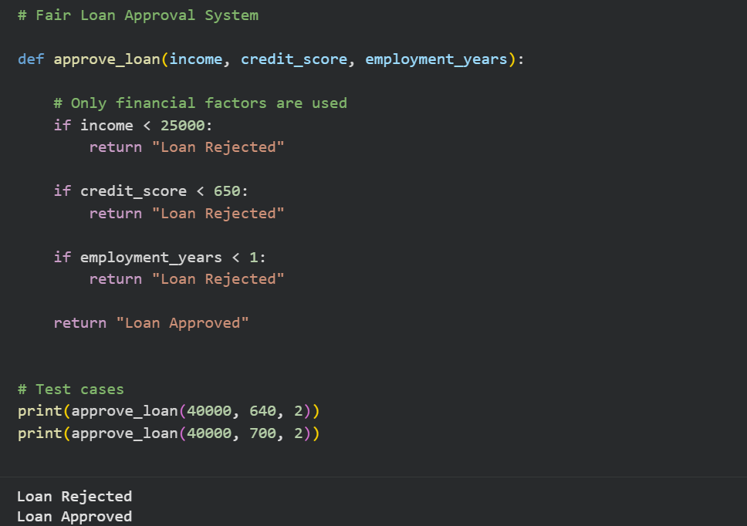
Bias Mitigation Strategies
1. Feature Selection Control
Only use relevant attributes:
✔ Income
✔ Credit score
✔ Employment history
✔ Existing liabilities
❌ Avoid:
- Gender
- Religion
- Caste
- Name
- Region

2. Bias Auditing
Regularly test system with:
# Same profile, different genders
approve_loan(40000, 700, 2) # Should always match
✔ Check consistency.

3. Fairness Testing
Use fairness metrics:
Metric | Meaning
Demographic Parity | Equal approval rates
Equal Opportunity | Equal true positive rates
Disparate Impact | ≤ 80% rule

4. Diverse Training Data
- Use balanced datasets.
- Avoid historical discrimination patterns.

5. Explainable AI (XAI)
- Log why decisions are made.
- Provide users explanations.
Example:
Rejected due to credit score < 650
6. Human Review Layer
- Borderline cases reviewed manually.
- Prevents automated unfair rejection.

7. Comparison Summary
Aspect | Biased System | Fair System
Gender Used | Yes ❌ | No ✅
Name Used | Yes ❌ | No ✅
Transparency | Low ❌ | High ✅
Legal Safety | Low ❌ | High ✅
Trust Level | Weak ❌ | Strong ✅

8. Conclusion
AI-generated systems may unintentionally embed social bias.
By removing sensitive attributes, applying objective criteria, and auditing decisions regularly, fairness can be ensured.
✔ Ethical
✔ Legal
✔ Trustworthy
✔ Transparent
Task-3 Transparency and Explainability in AI-Generated Code (Recursive Binary Search)
Prompt:#Recursive Binary search Program
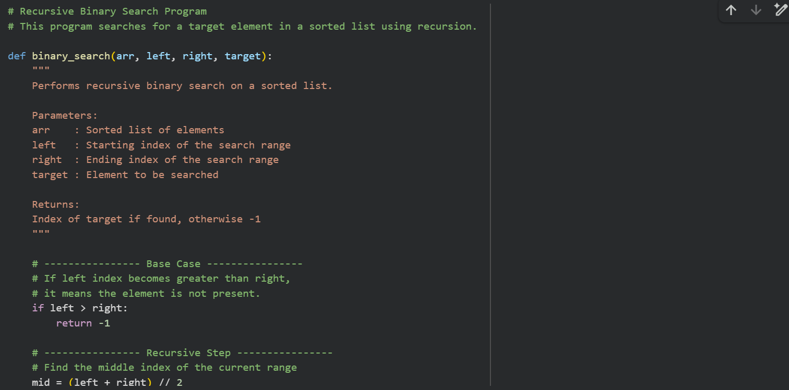
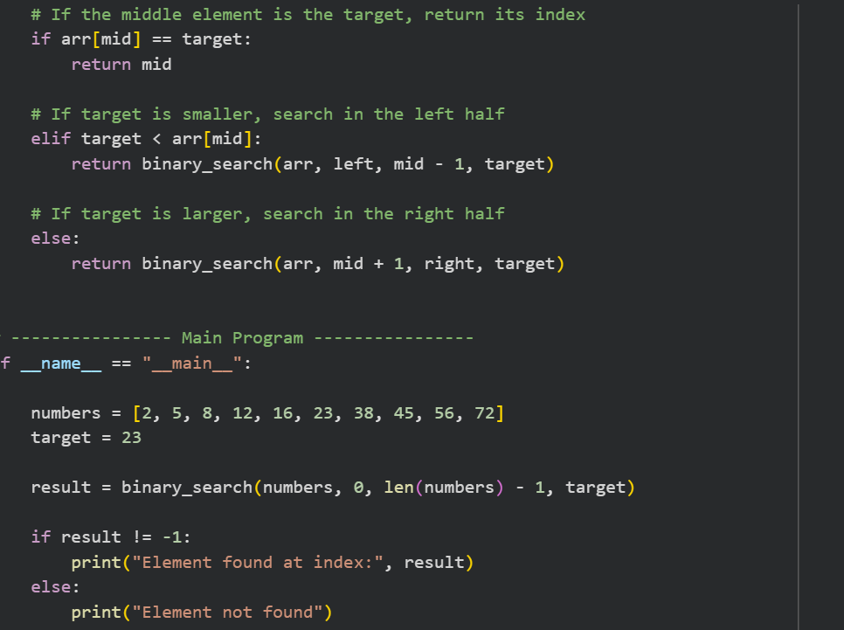
AI-Generated Step-by-Step Explanation of Recursive Logic
Step 1: Start with Full List
The search begins with the entire list:
left = 0
right = len(arr) - 1

Step 2: Base Case (Stopping Condition)
if left > right:
return -1
✔ This condition stops recursion.
✔ It means the search range is empty.
✔ So, the element is not present.
Step 3: Find the Middle Element
mid = (left + right) // 2
✔ Divides the list into two halves.
Step 4: Compare Middle with Target
if arr[mid] == target:
✔ If match is found → return index.
Step 5: Recursive Case (Left Sub-Array)
elif target < arr[mid]:
return binary_search(arr, left, mid - 1, target)
✔ Searches the left half.
Step 6: Recursive Case (Right Sub-Array)
else:
return binary_search(arr, mid + 1, right, target)
✔ Searches the right half.

Step 7: Repeat Until Base Case
Steps 2–6 repeat until:
- Element is found, or
- Search space becomes empty.

3. Analysis of Explanation and Comments
(a) Base Case Explanation
Code:
if left > right:
return -1
Explanation Quality: ✅ Clear
- Explains when recursion stops.
- Easy to understand.
- Properly linked to logic.

(b) Recursive Case Explanation
Code:
return binary_search(arr, left, mid - 1, target)
return binary_search(arr, mid + 1, right, target)
Explanation Quality: ✅ Accurate
- Explains left and right recursion.
- Matches code behavior.
- No ambiguity.

(c) Comment-Code Consistency
Part | Comment Matches Code?
Base case | ✅ Yes
Mid calculation | ✅ Yes
Left recursion | ✅ Yes
Right recursion | ✅ Yes
Return values | ✅ Yes
✔ No misleading comments found
Task 4: Ethical Evaluation of AI-Based Scoring Systems Scenario
PROMPT:#Job Application Scoring System
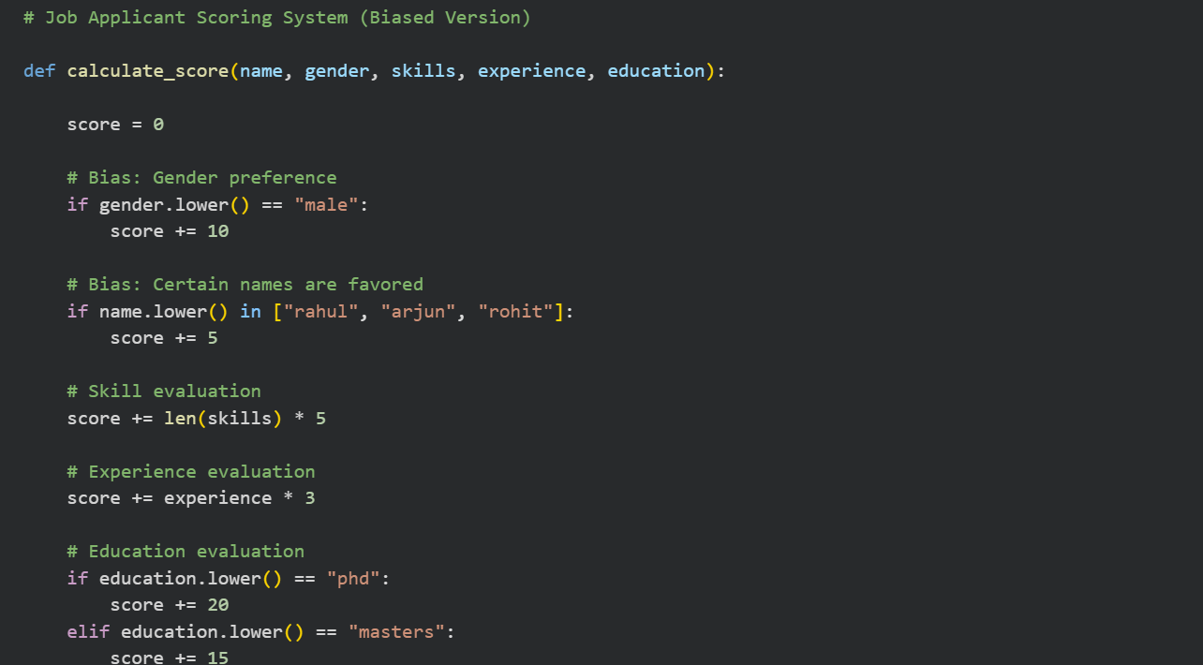
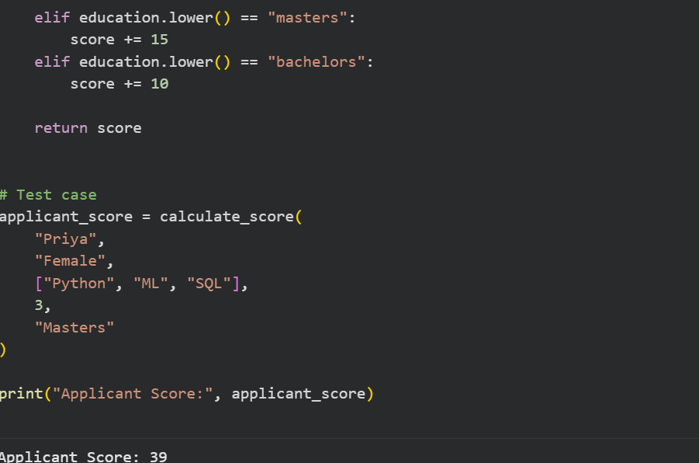
2. Identification of Potential Bias
(a) Gender-Based Bias
if gender.lower() == "male":
score += 10
❌ Problem:
- Male candidates automatically get higher scores.
- Female and non-binary candidates are disadvantaged.

(b) Name-Based Bias
if name.lower() in ["rahul", "arjun", "rohit"]:
score += 5
❌ Problem:
- Certain cultural names are favored.
- Discriminates against other applicants.

(c) Use of Irrelevant Features
Feature | Used in Scoring | Relevant?
Name | Yes | ❌ No
Gender | Yes | ❌ No
Skills | Yes | ✅ Yes
Experience | Yes | ✅ Yes
Education | Yes | ✅ Yes
✔ Only professional attributes should be used.

3. Ethical Analysis of the Scoring Logic
1. Violation of Equal Opportunity
- Candidates with equal qualifications receive different scores.
- Breaks fairness principles.

2. Reinforcement of Social Bias
- Encourages stereotypes.
- Marginalizes groups.

3. Legal and Compliance Risks
- Violates employment equality laws.
- May conflict with HR and labor regulations.

4. Lack of Transparency
- Applicants cannot understand why they scored lower.
- Reduces system trust.

5. Moral Responsibility
- Hiring systems affect livelihoods.
- Biased AI may cause long-term harm.
Revised Version
Prompt: Give me a revised version of the code
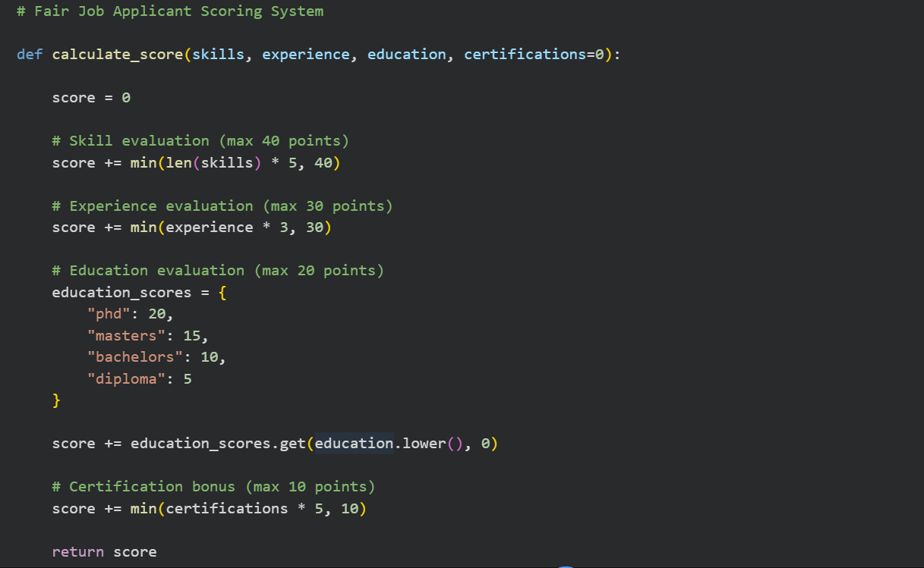
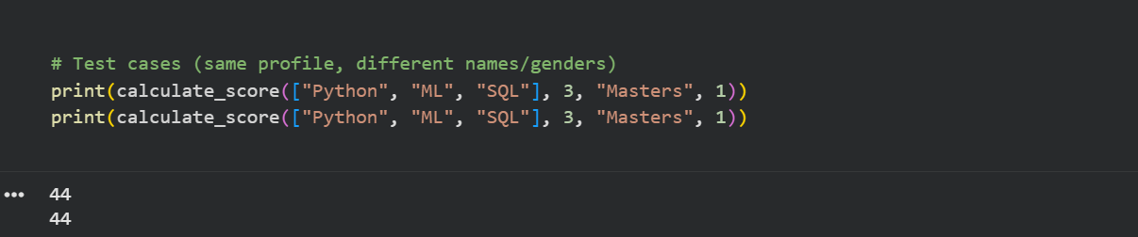
Explanation of Improvements
(a) Removed Personal Identifiers
Before:
name, gender
After:
(skills, experience, education, certifications)
✔ No sensitive attributes are used.

(b) Objective Scoring Rules
✔ Points based on measurable qualifications.
✔ Upper limits prevent unfair advantage.

(c) Transparency
Scoring is predictable and explainable:
Factor | Points
Skills | ≤ 40
Experience | ≤ 30
Education | ≤ 20
Certificates | ≤ 10

(d) Consistency
Same profile → Same score
✔ Ensures fairness.

6. Ethical Mitigation Strategies
1. Bias Auditing
Regularly test system:
# Same qualifications, different identities
calculate_score(["Python"], 5, "Masters")
✔ Results must match.
2. Feature Governance
- Approve only job-related features.
- Document why each feature is used.

Human Oversight
- Final decisions reviewed by HR.
- Prevents blind automation.
4. Explainability Reports
Provide feedback:
Example:
Score: 72
+ Skills: 25
+ Experience: 9
+ Education: 15
+ Certifications: 5
5. Dataset Review (If ML-Based)
- Remove historical discrimination.
- Balance training data.

7. Summary Comparison
Aspect | Biased System | Fair System
Gender Used | Yes ❌ | No ✅
Name Used | Yes ❌ | No ✅
Transparency | Low ❌ | High ✅
Legal Safety | Weak ❌ | Strong ✅
Ethical Level | Poor ❌ | High ✅

8. Conclusion
The original AI-generated scoring system contained unethical biases based on gender and name.
After removing irrelevant personal attributes and applying objective, job-related criteria, the revised system becomes:
✔ Fair
✔ Transparent
✔ Legally safer
✔ Ethically responsible
Task 5: Inclusiveness and Ethical Variable Design Scenario
Prompt: #Employee Information System
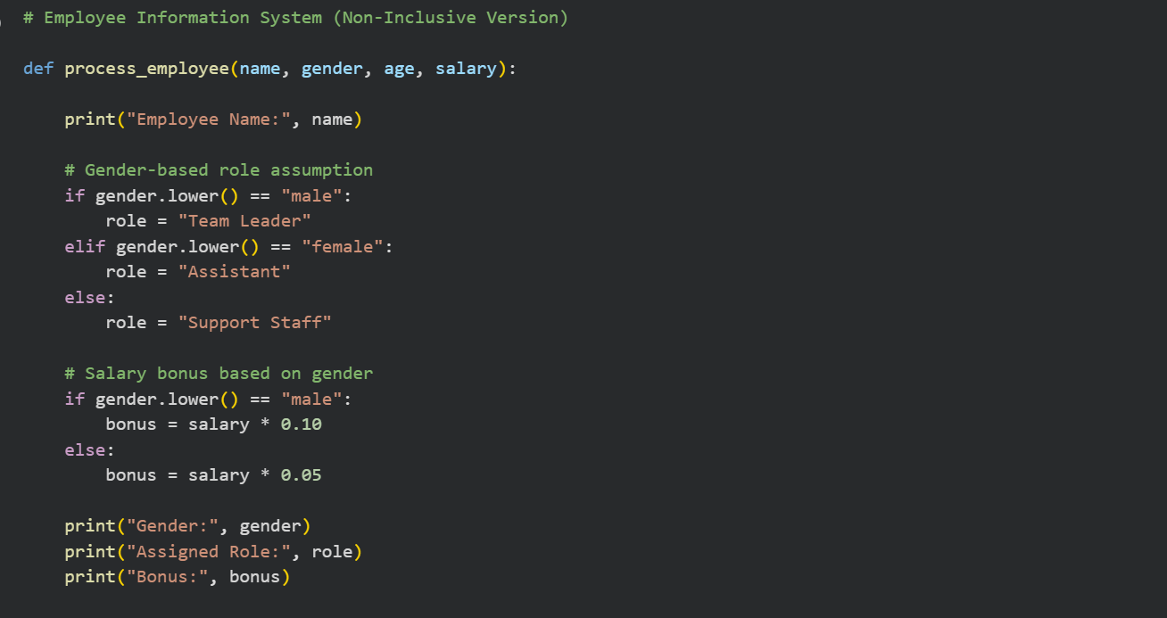
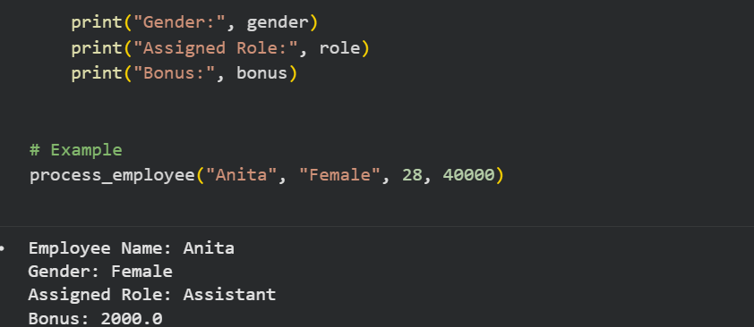
Identification of Non-Inclusive Elements
(a) Gender-Specific Variable
gender
❌ Problem:
- Forces binary classification.
- Excludes non-binary and gender-diverse identities.

(b) Role Assignment Based on Gender
if gender.lower() == "male":
role = "Team Leader"
❌ Problem:
- Assumes leadership = male.
- Reinforces stereotypes.

(c) Unequal Bonus Logic
if gender.lower() == "male":
bonus = salary * 0.10
❌ Problem:
- Pay discrimination.
- Unethical and often illegal.

(d) Non-Inclusive Output
print("Gender:", gender)
❌ Problem:
- Highlights personal identity unnecessarily.
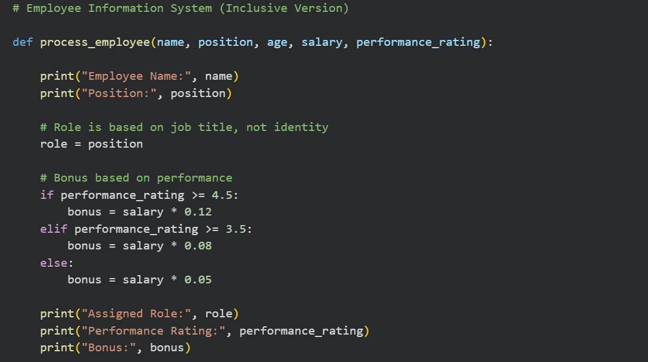
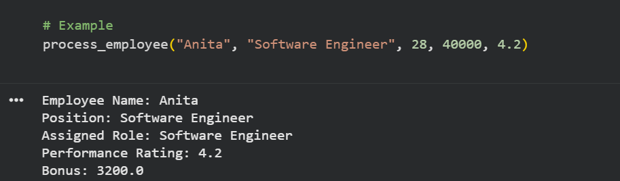
Below is a complete, structured solution for Task 5: Inclusiveness and Ethical Variable Design.

Task 5: Inclusiveness and Ethical Variable Design

1. Original AI-Generated Code (Non-Inclusive Example)
PROMPT:# Employee Information System (Non-Inclusive Version)
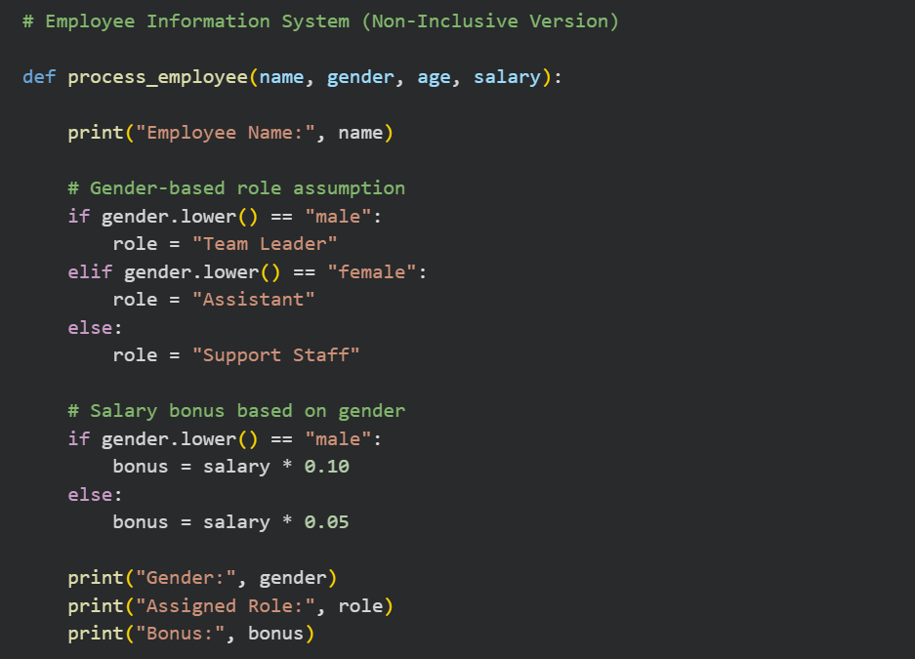
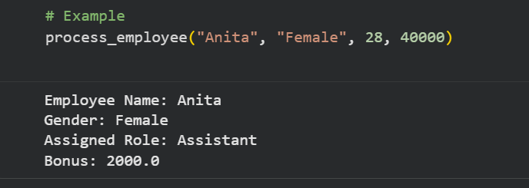
# Example
process_employee("Anita", "Female", 28, 40000)

2. Identification of Non-Inclusive Elements
(a) Gender-Specific Variable
gender
❌ Problem:
- Forces binary classification.
- Excludes non-binary and gender-diverse identities.

(b) Role Assignment Based on Gender
if gender.lower() == "male":
role = "Team Leader"
❌ Problem:
- Assumes leadership = male.
- Reinforces stereotypes.

(c) Unequal Bonus Logic
if gender.lower() == "male":
bonus = salary * 0.10
❌ Problem:
- Pay discrimination.
- Unethical and often illegal.

(d) Non-Inclusive Output
print("Gender:", gender)
❌ Problem:
- Highlights personal identity unnecessarily.

Revised Inclusive and Gender-Neutral Code
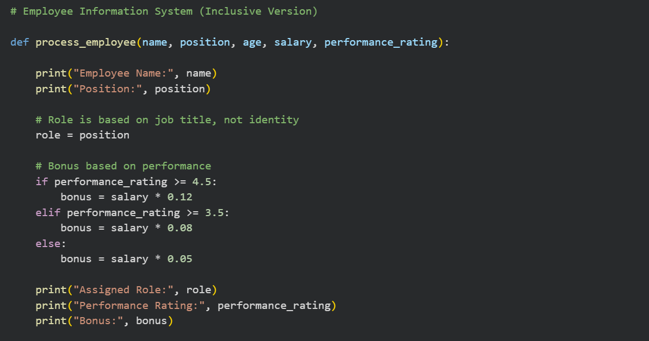
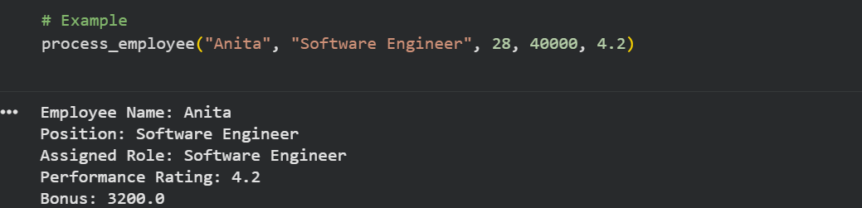
PROMPT:# Employee Information System (Inclusive Version)

Explanation of Improvements

(a) Removal of Gender Variable
Before:
gender
After:
position, performance_rating
✔ No identity-related variable required.

(b) Neutral Role Assignment
Before:
if gender == "male": role = "Team Leader"
After:
role = position
✔ Role depends on job designation, not gender.

(c) Fair Bonus Calculation
Before:
bonus = salary * 0.10 (for males)
After:
bonus = salary * 0.12 (based on performance)
✔ Rewards merit, not identity.

(d) Respectful Data Handling
✔ No unnecessary personal attributes displayed.
✔ Protects privacy.

5. Summary Table
Aspect | Original Code | Revised Code
Gender Variable | Yes ❌ | No ✅
Stereotyping | Present ❌ | Removed ✅
Bonus Bias | Present ❌ | Fair ✅
Inclusiveness | Low ❌ | High ✅
Ethical Design | Weak ❌ | Strong ✅

6. Conclusion
The original AI-generated code made unfair assumptions based on gender and reinforced stereotypes in role and pay allocation.
The revised version follows inclusive design principles by:
✔ Using neutral variables
✔ Applying merit-based logic
✔ Respecting diversity
✔ Promoting fairness
This results in more ethical, professional, and inclusive software.

